- Where did marriages take place during the Middle Ages?
In the earl Middle Ages, Renaissance weddings often took place in the bride's house but nobles used to have ceremonies in a medieval castle. In the later Middle Ages, they usually took place in a chapel or at the Church door.

- Why were marriage contracts arranged?
Marriage contracts were arranged to thick dynasties ( in the case of nobles people) or to have the possibility to own a house. In the noble society, they could acquire a piece of land by gathering together titles ( the terms were conveyed with the nuptials)

- Who performed the marriage ceremony
it was usually performed by a priest or a bishop, it depended on the social class

- What was the common age for marriage?
Boys were allowed to marry at 14 and girls at 12, but they usually waited until they were at least 16 before wedding. Nobles used to wait a bit longer than peasants, except when their marriage was arranged.

- What is a betrothal?
The betrothal in the Middle Ages is pretty different from nowadays. It is still before the marriage ceremony, but it was a lot more important during the Renaissance. It was kind of the same as the wedding ceremony but they had to wait 40 days between them. The groom had to pay a deposit that would cost 4 times more if he decided not to marry the bride. They needed to give at least 1/3 of their estate to ensure their wife's livelihood ( in case of they died suddenly).

- What was the goal of a Renaissance wedding?
Unfortunately, the chivalric novels we read about Middle Ages were as rare as fairy and Disney tale nowadays . Hymeneal was just made by arrangement between parents and surely not for love.

- Describe the common wedding attire during this period.
Renaissance attire is the reflect of the beginning of the trade made around the world. Nobles used to wear a lot of bright colors on their dresses Silk was reserved for upper classes since some peasants were forbidden to wear it, or even to simply possess it.
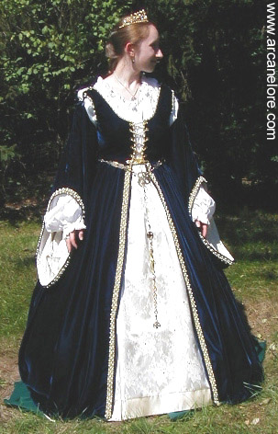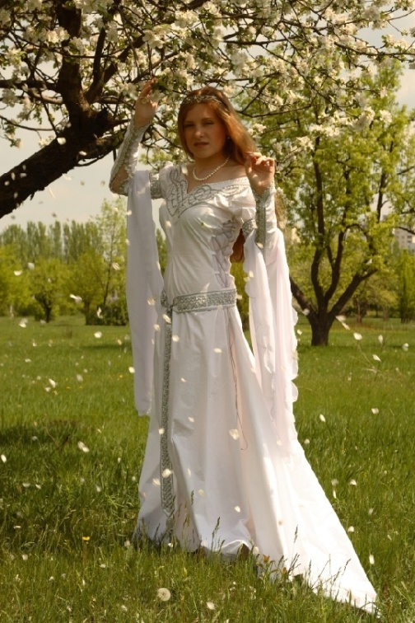
- Describe what foods might be served at a wedding feast.
Guests used to eat with their fingers. They served them quail, goose, venison, and every kind of meat that could have been found around the wedding's place. They often had some vegetables, but as they didn't know how to cook many of them there were just a few vegetables served ( carrots, cabbage,...). They drank milk, wine, water, beer, ale and mead. .

