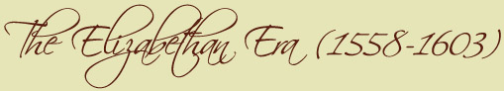
Skakespeare : His life and times

Religious Life in the 1500s and 1600s

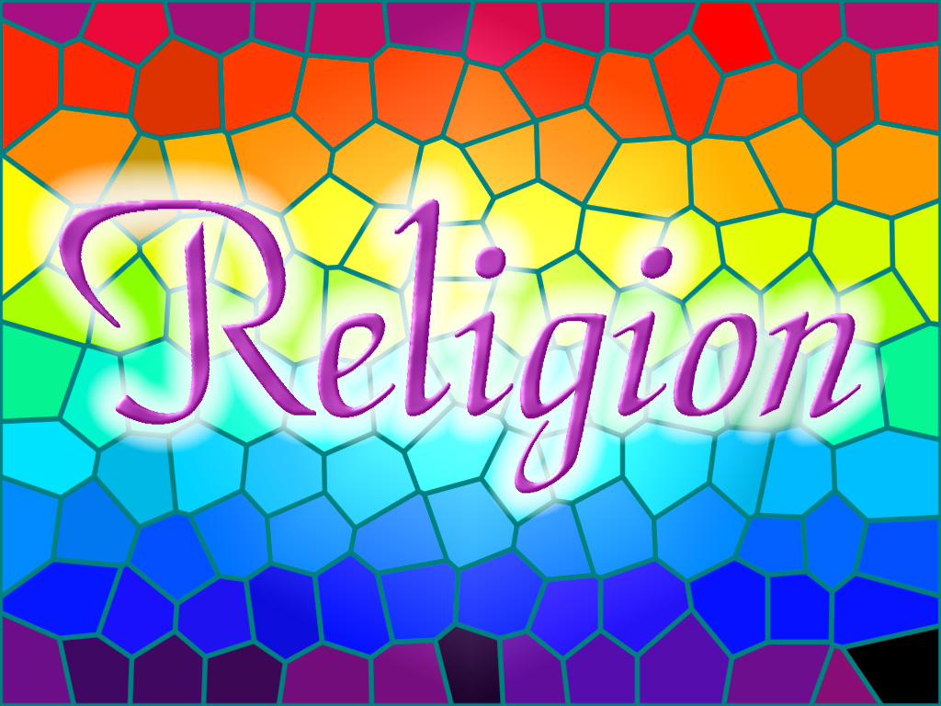 | During the Elizabethan Era, there were catholic and protestant people in England.  In fact, the religion changed because of the monarch's religion who was at the head of the state.  That's why, all persons who didn't follow the state religion received punishments, was victims of tortures or executions (burnt on fire …).

While this era, the state was governed by The Tudor Dynasty from 1485 to 1603.

- From 1485 to 1509, Henry VII was at the head of the state. During his reign, England was catholic.
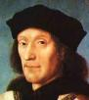
- After, from 1509 to 1547, Henry VIII retook the familial light and kept the England catholic. Moreover he was called the « defender of the faith » by the pope, before having argument with him.
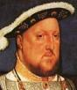
- The Edward VI's goverment make the England protestant.
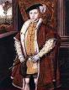
- Catholicism came back with Mary I, from 1553 to 1558.
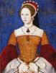
- However, the fight wasn't ended ! Indeed Elizabeth I was protestant ! She reigned from 1558 to 1603 and achieved this historical period.
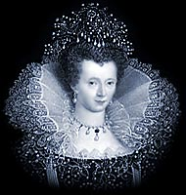
It's interesting to notice that to help the stop of violence over religion, Elizabeth I banned all performances of religions plays and stories, except in Church.

Sources : www.elizabethan-era.org.uk

