Education

Questions:

What did education depend on?

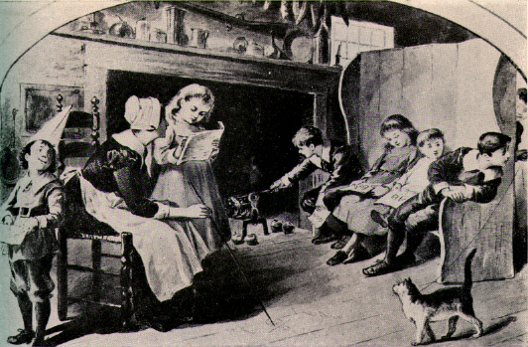
The education in Elizabethan England is influenced. Indeed, she depended of monarch of the time. The religious of King or of Queen reflects the style of education. At that era they are two dominant religion: - Catholics
- Protestants
Furthermore, the financial standing and social class of the family depends.

What was the main purpose of schooling?

The main purpose of education was to teach children how to behave in their social class. For each class there was a specific teacher.

Why were students taught Latin?

It was used in Europe but too in the world. For exemple in the world of affairs ( men of affairs be able to speak Latin to communicate) . They studied Latin grammar and vocabulary.
Student were taught Latin because it was the language of Education.

What were girls from weatthy families educated in?
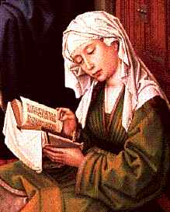
The girls from wealthy families learnt to read, write, keep accounts, govern a household, manage a estate. They leart too make salves and pratice sugery. The dance and the sing ( social competence) were too at program. At middle of 16eme century, favour protestants private schools for girls were constructed.
Why were courses in university conducted in Latin?

The courses in university conducted were in Latin because a person who wanted to pursue his career must have a minimum knowledge of Latin for succeed.

Sources:
-www.elizabethanenglandlife.com/education-in-elizabethan-england.html
-http://elizabethan.org/compendium/54.html
-http://internetshakespeare.uvic.ca/Library/SLT/ideas/education/boys.html
« « girls.html

