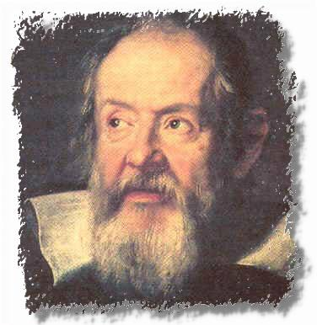
Galileo Galilee
He was a physicist, mathematician and philosopher.

1563 : he invented the themoscope, Galilée thermoscope indicated temperature differences and was the predecessor to the termometer.

He was the first physicist to use the telescopes. Improving them, he observed the moon , the sky, the planets and gather a number of theories.

