Vorname......................................................... Datum .........................................................................



# Minus

## Schreibe die passende Rechnung:

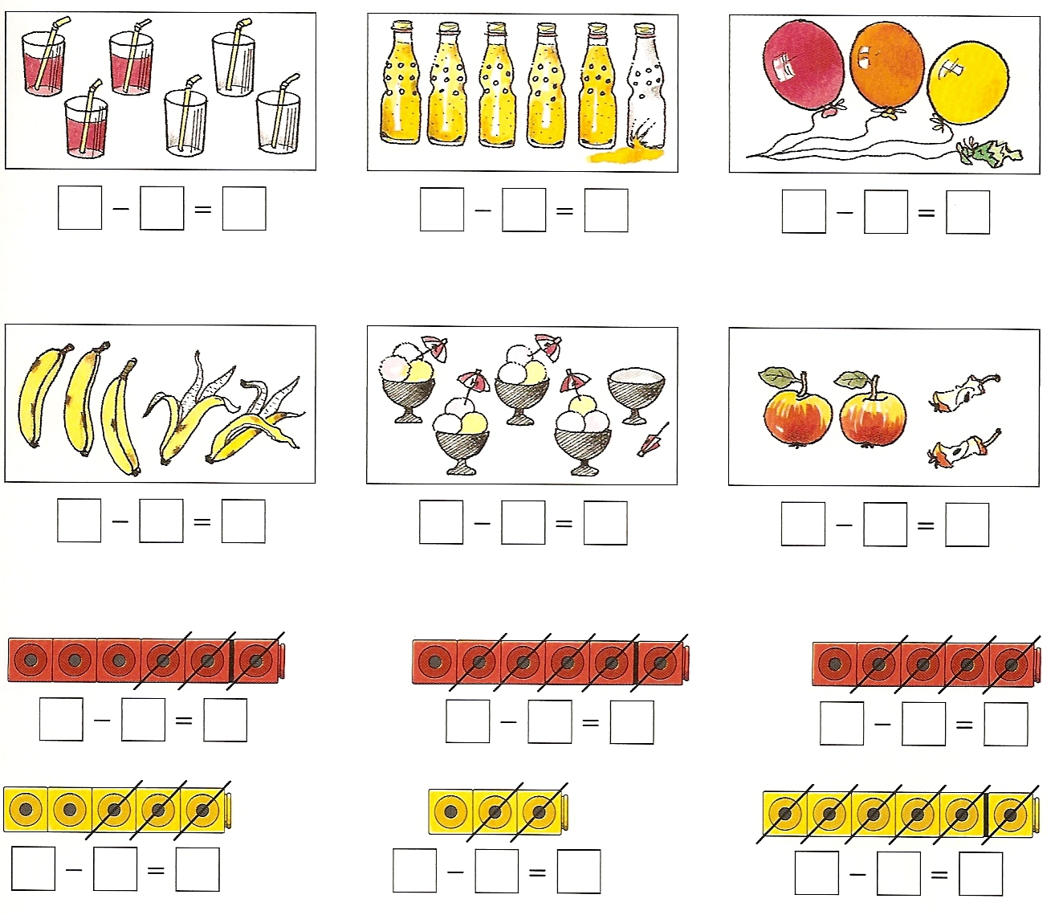

|  |  |  |  |
| --- | --- | --- | --- |
|  |  |  |  |
|  |  |  |  |
|  |  |  |  |
|  |  |  |  |
|  |  |  |  |

## Streiche durch und rechne:

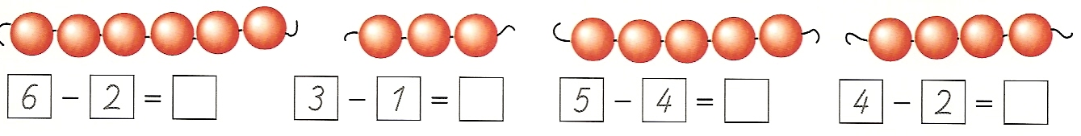

## Zeichne und rechne:

|  |  |  |  |
| --- | --- | --- | --- |
|  |  |  |  |
| 7 – 1 = | 7 – 2 = | 8 – 1 = | 6 – 4 = |
|  |  |  |  |
|  |  |  |  |
| 8 – 3 = | 9 – 4 = | 10 – 5 = | 5 – 2 = |

|  |  |  |  |
| --- | --- | --- | --- |
|  |  |  |  |
| 5 – 3 = | 7 – 4 = | 8 – 5 = | 8 – 6 = |
|  |  |  |  |
|  |  |  |  |
| 9 – 7 = | 4 – 1 = | 9 – 6 = | 7 – 5 = |

## Zeichne und ergänze:

|  |  |  |  |
| --- | --- | --- | --- |
|  |  |  |  |
| 8 - …… = 7 | 9 - …… = 6 | 7 - …… = 5 | 10 - …… = 2 |